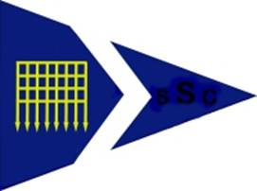
Shotley Sailing Club Dinner Dance

Saturday 12 March 2022 @ Fynn Valley Golf Club
£32 per person if received by 31 Oct, £6 per coach place

Names of those wishing to attend the dinner dance | Coach place
Member:
Partner:
Guest 1:
Guest 2:
Payment of £32 for dinner dance & £6 coach pp to be received by
Sun 31 October

Please be aware that places on the coach will be on a first paid, first served basis.

Payment by bank transfer to:

Shotley Sailing Club

HSBC Sort code 40–25–31 account number 01703145

with ref DD (or DDC if you want coach places)
.
Payments must be received by Sunday 31 October
as after this the cost for the dinner dance will rise to £35

Meal choices & coach stop details are required at a later date.

Please return form(s) to:
nicki.clayton@ntlworld.com
once you have made the bank transfer
Any queries, please contact,
Tom or Nicki Clayton on (01473) 255147

